Terraform Challenge
Write a code using Terraform that deploys and achieves the following:-
- Create an EC2 Instance on AWS Cloud using the below-mentioned ubuntu AMI and instance_type. Or, (You can use of your choice as well) ami = "ami-0461b1436c9b3c1a3" instance_type = "t2.micro"

First created a main.tf file and userdata.sh
In main.tf
provider "aws" {
region = "us-east-1"
}

resource "aws_security_group" "web_sg" {
name = "web-security-group"
description = "Allow SSH, Nginx, and Docker app traffic"

ingress {
description = "SSH Access"
from_port = 22
to_port = 22
protocol = "tcp"
cidr_blocks = ["0.0.0.0/0"]
}

ingress {
description = "Nginx Web Server"
from_port = 8080
to_port = 8080
protocol = "tcp"
cidr_blocks = ["0.0.0.0/0"]
}

ingress {
description = "Docker App"
from_port = 8000
to_port = 8000
protocol = "tcp"
cidr_blocks = ["0.0.0.0/0"]
}

egress {
from_port = 0
to_port = 0
protocol = "-1"
cidr_blocks = ["0.0.0.0/0"]
}
}

resource "aws_instance" "ec2" {
ami = "ami-0b6d9d3d33ba97d99"
instance_type = "t3.micro"
vpc_security_group_ids = [aws_security_group.web_sg.id]

user_data = file("userdata.sh")

tags = {
Name = "Terraform-EC2"
}
}

output "public_ip" {
value = aws_instance.ec2.public_ip
description = "EC2 Public IP — use this to test in browser"
}
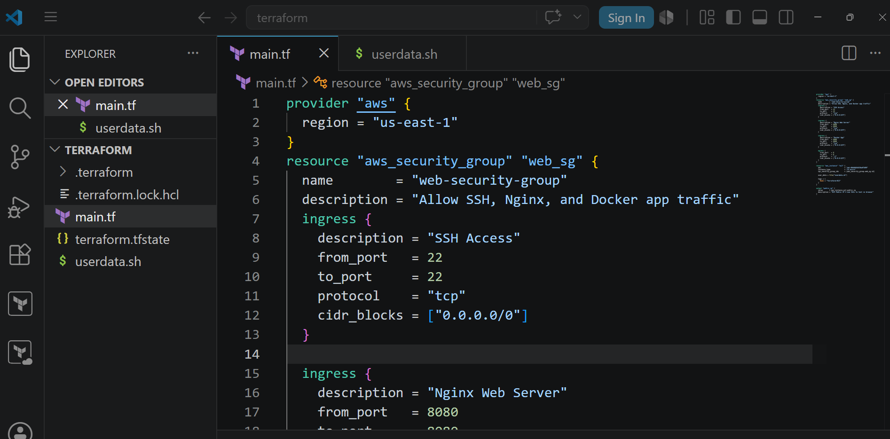
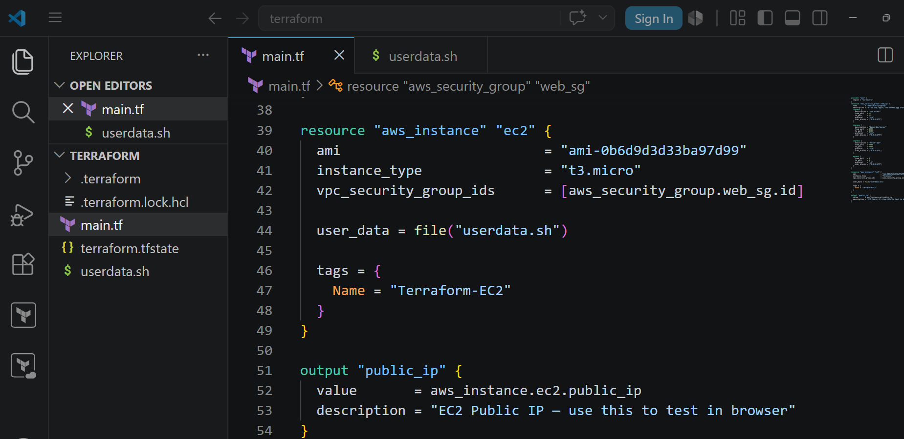
In userdata.sh
#!/bin/bash
export DEBIAN_FRONTEND=noninteractive
exec > /var/log/userdata.log 2>&1

echo "=== Step 1: Install nginx, git, curl, golang ==="
apt-get update -y
apt-get install -y nginx git curl ca-certificates gnupg golang-go

echo "=== Step 2: Configure Nginx on port 8080 ==="
tee /etc/nginx/sites-available/default > /dev/null <<'EOL'
server {
listen 8080;

location / {
proxy_pass http://localhost:8000;
proxy_set_header Host $host;
proxy_set_header X-Real-IP $remote_addr;
}
}
EOL

nginx -t && systemctl restart nginx && systemctl enable nginx

echo "=== Step 3: Install Docker CE ==="
install -m 0755 -d /etc/apt/keyrings

curl -fsSL https://download.docker.com/linux/ubuntu/gpg \
| gpg --dearmor -o /etc/apt/keyrings/docker.gpg

chmod a+r /etc/apt/keyrings/docker.gpg

echo "deb [arch=$(dpkg --print-architecture) signed-by=/etc/apt/keyrings/docker.gpg] \
https://download.docker.com/linux/ubuntu \
$(. /etc/os-release && echo "$VERSION_CODENAME") stable" \
| tee /etc/apt/sources.list.d/docker.list > /dev/null

apt-get update -y
apt-get install -y docker-ce docker-ce-cli containerd.io docker-compose-plugin

systemctl enable docker
systemctl start docker

echo "=== Step 4: Clone repo ==="
cd /home/ubuntu
git clone https://github.com/betawins/cricbuzz-docker-hello-world.git
cd cricbuzz-docker-hello-world

echo "=== Step 5: Build static Go binary ==="
export HOME=/root
CGO_ENABLED=0 GOOS=linux GOARCH=amd64 go build -a -ldflags='-extldflags=-static' -o hello_world .

echo "=== Step 6: Write docker-compose.yml ==="
cat > docker-compose.yml <<'COMPOSE'
services:
cricbuzz-app:
build:
context: .
dockerfile: Dockerfile
container_name: cricbuzz-container
ports:
- "8000:8080"
restart: unless-stopped
logging:
driver: "json-file"
options:
max-size: "10m"
max-file: "3"
volumes:
- /var/log:/var/log
COMPOSE

echo "=== Step 7: Build and start container ==="
docker compose build --no-cache
docker compose up -d

echo "=== Step 8: Stream container logs to /var/log/cb.log ==="
touch /var/log/cb.log
chmod 644 /var/log/cb.log

nohup docker compose logs -f --no-color >> /var/log/cb.log 2>&1 &

echo "=== Step 9: Configure log rotation for cb.log ==="
cat > /etc/logrotate.d/cb <<'EOF'
/var/log/cb.log {
su root root
daily
rotate 7
compress
delaycompress
missingok
notifempty
copytruncate
dateext
dateformat -%Y-%m-%d
create 644 root root
}
EOF

echo "=== Log rotation configured ==="

echo "=== DONE ==="
docker ps
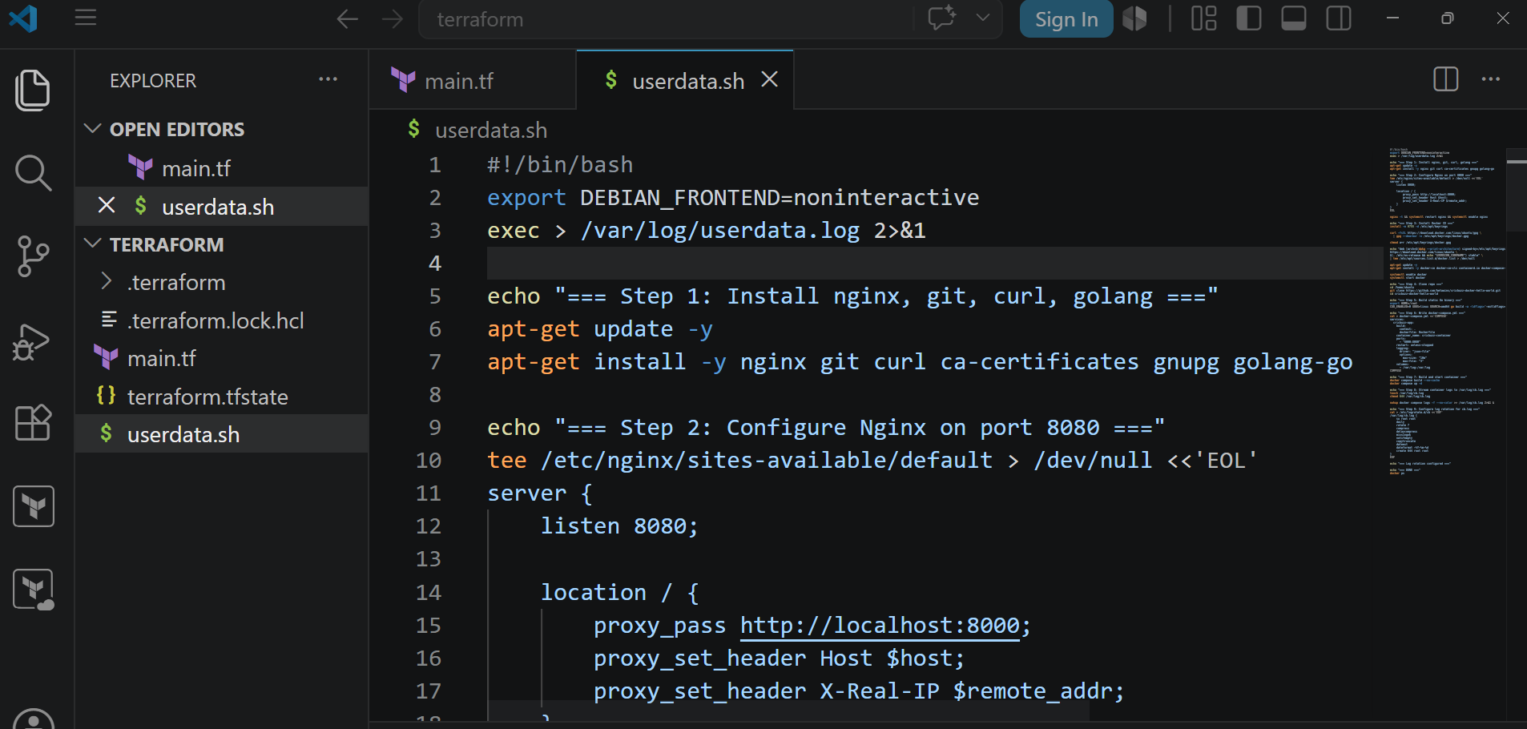
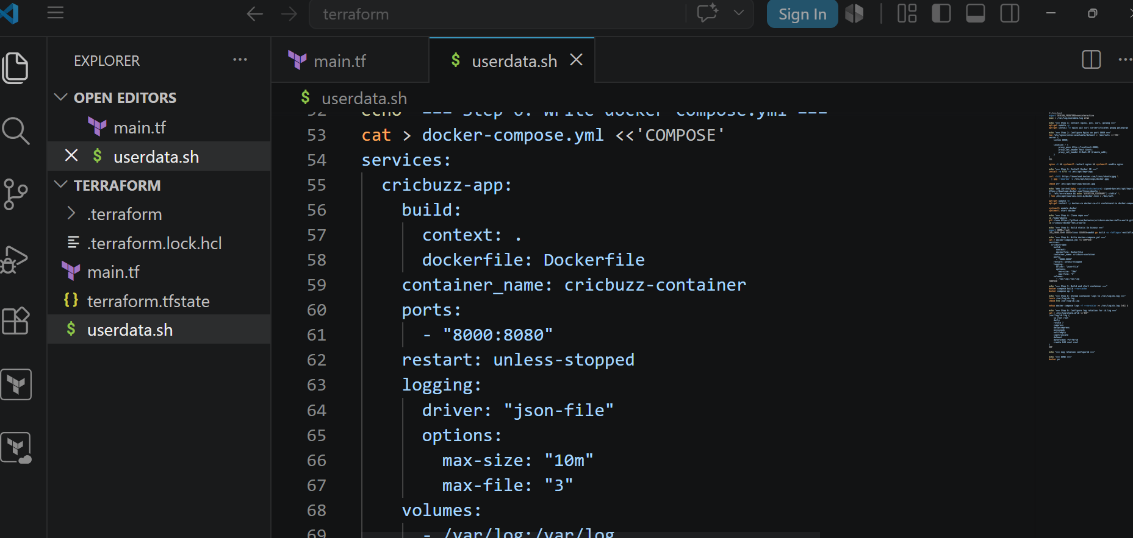
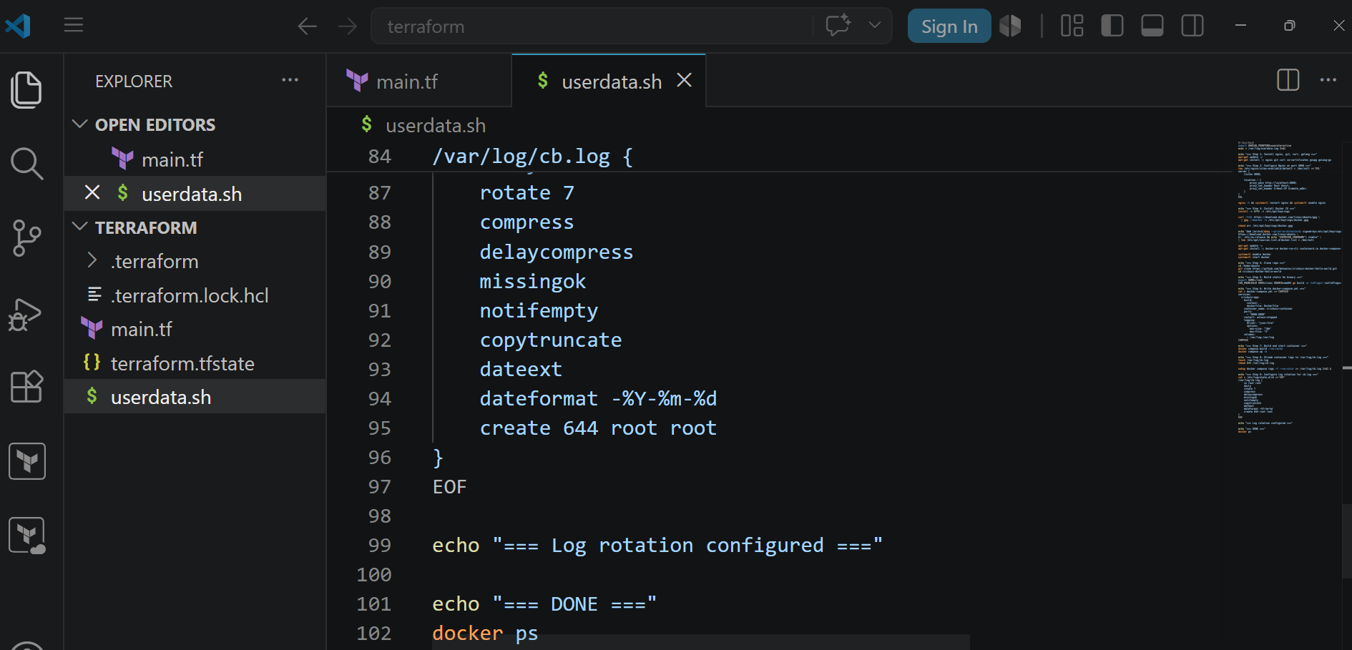
No do terraform init
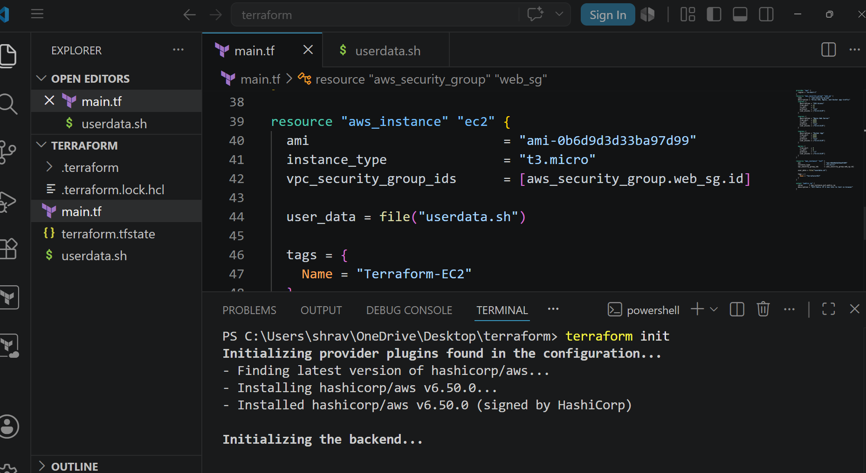
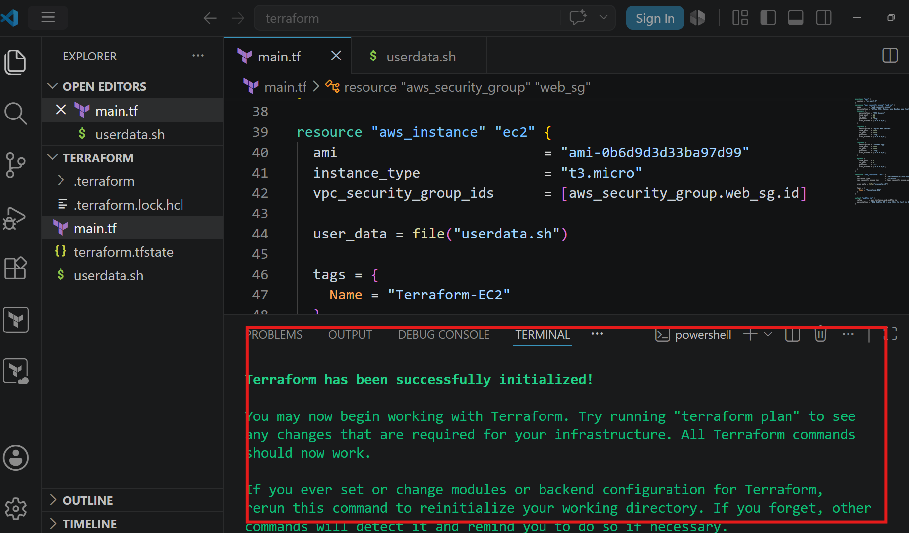
Now do terraform plan
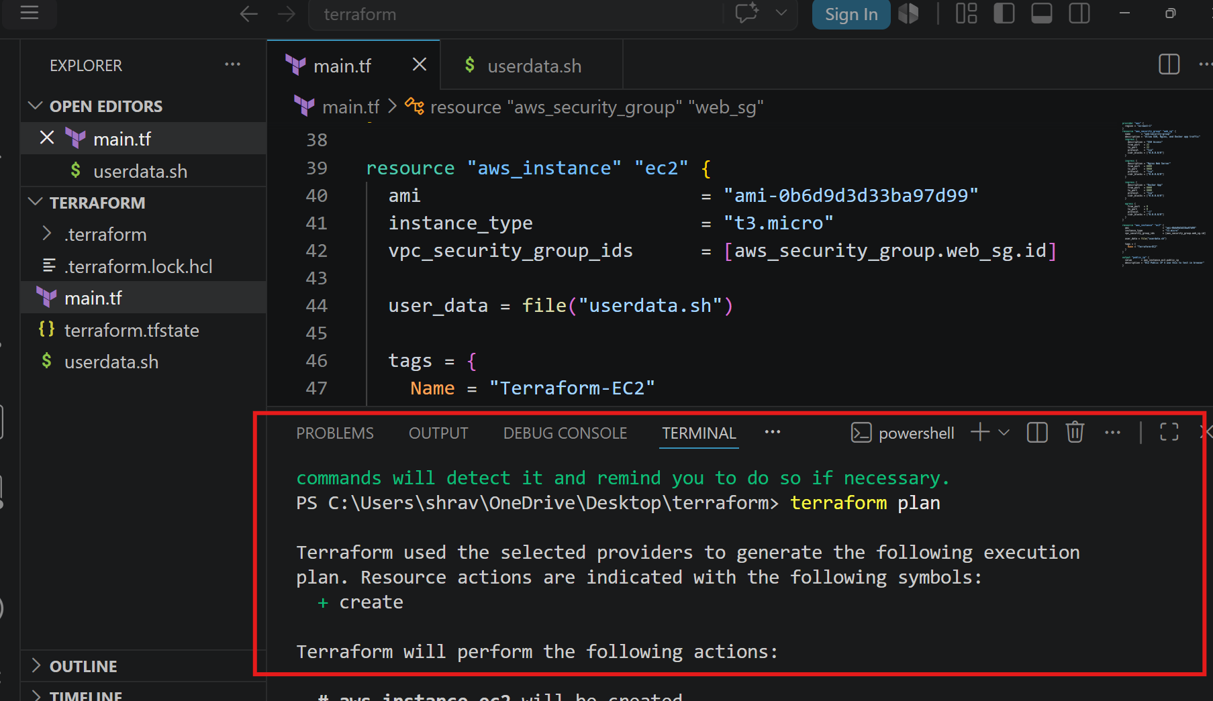
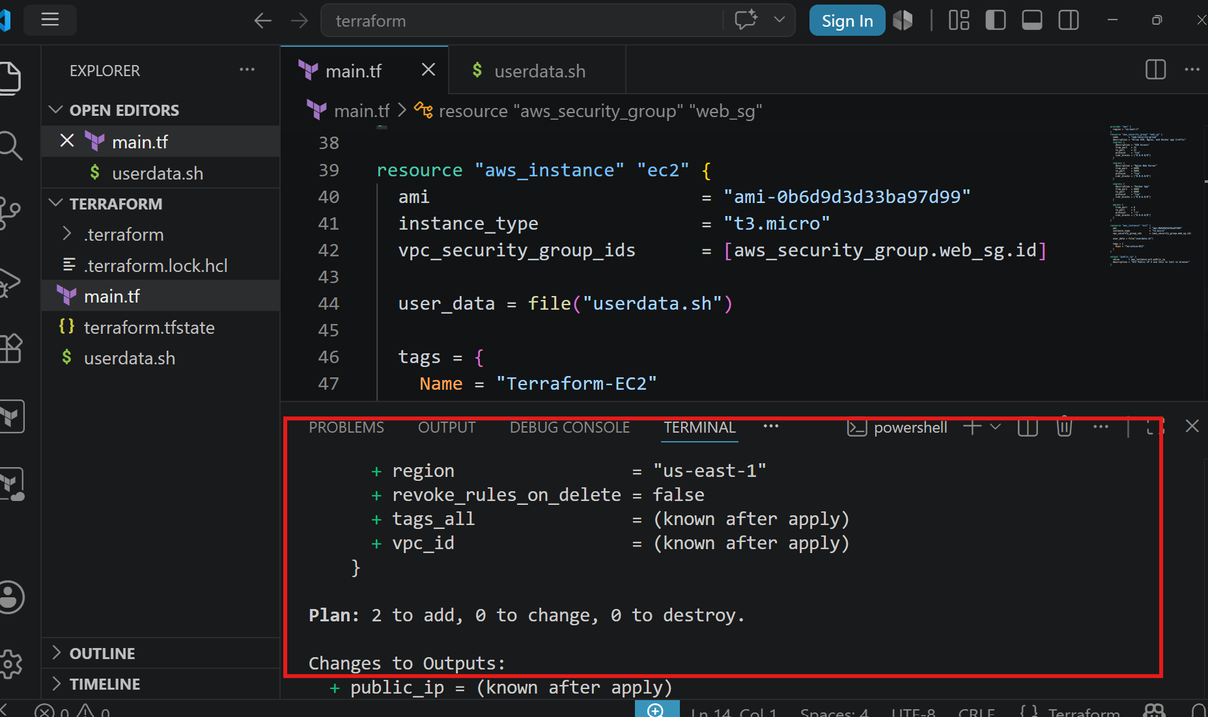
Now do terraform apply
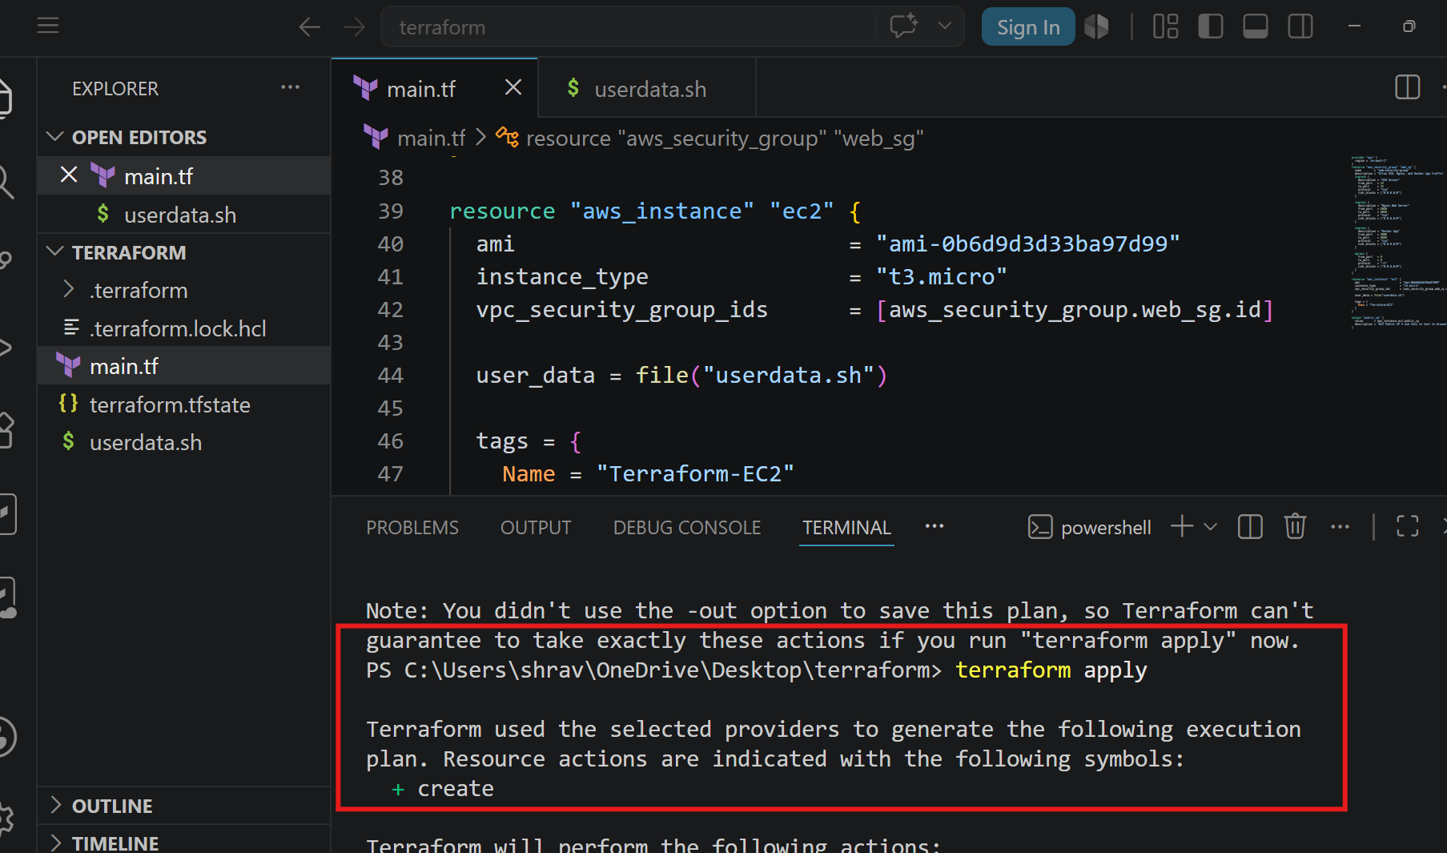
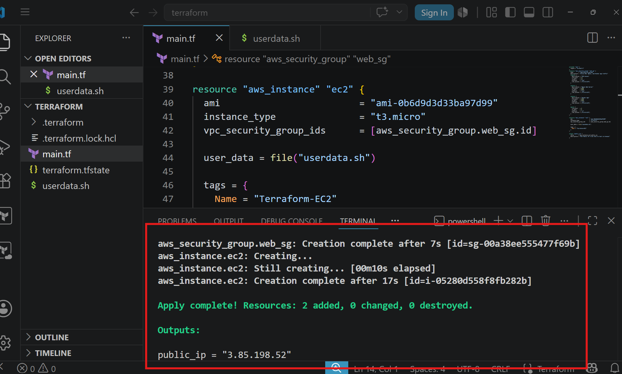
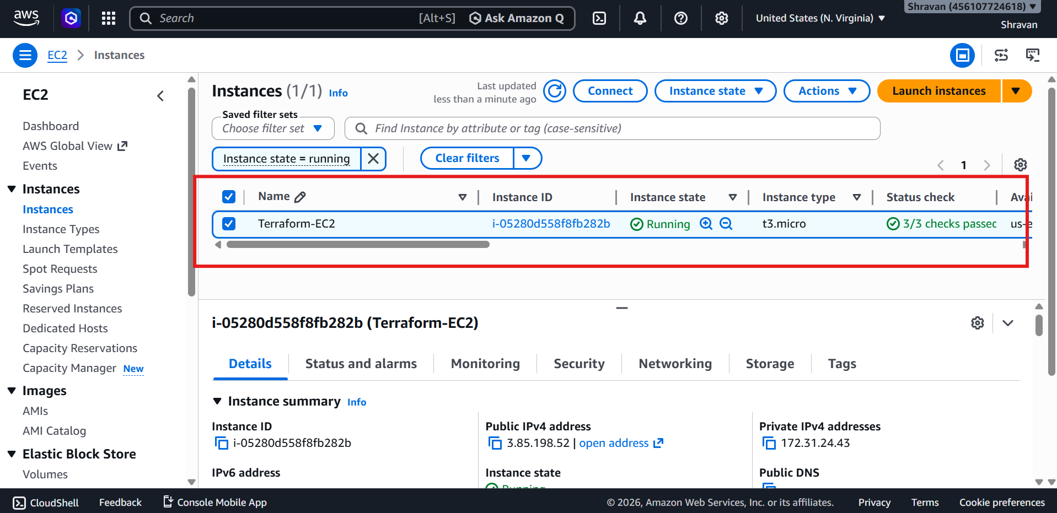

- Install a web server on the same EC2 Instance. The web server should listen on port 8080.
- You can check
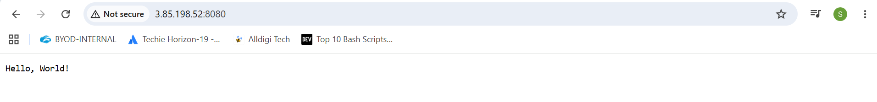
- Create a Docker-compose file for the project:https://github.com/betawins/cricbuzz-docker-hello-world.gitand point it to port 8000.
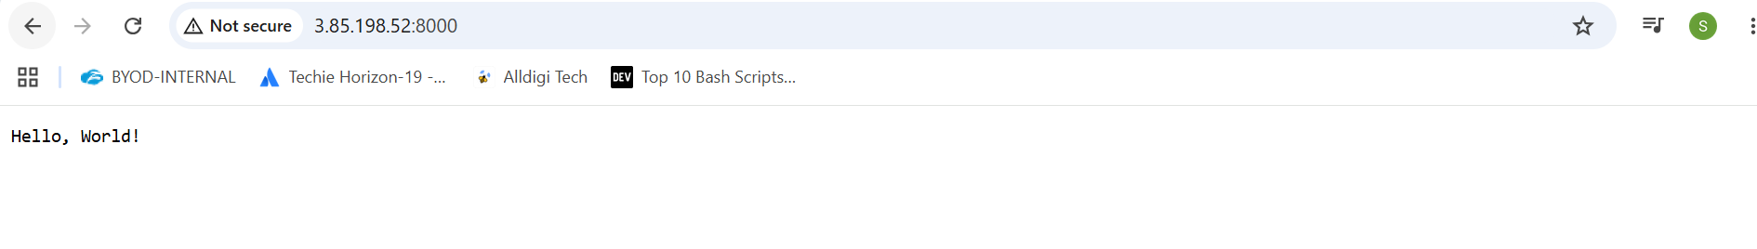
- Make the web server point to the above service so that 8080 returns the response from the Docker service.
- Configure to Save the Logs in the location /var/log/cb.log
- Write the Log rotate configuration for the above file
